Monarch Therapists
Helps clients understand & overcome the
STRESS …ANXIETY… DEPRESSION CYCLE

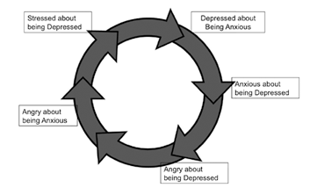

Break the cycle of STRESS…ANXIETY…DEPRESSION

Schedule an appointment with a therapist today and learn to
BALANCE MIND…BODY…SPIRIT

BALANCE MIND: think positively
Read Affirmations; Use Guided Meditations on You Tube; Listen to Uplifting Music;
Develop a Support Network of LIFE SAVERS.

BALANCE BODY: discharge negativity
Walk; Kickbox; Do Yoga; Eat Healthy; Play; Sleep Well; Garden; Dance; Squeeze a
STRESS BALL.

BALANCE SPIRIT: seek internal peace
Pray; Breathe Belly Breaths; Love Yourself Unconditionally; Practice SERENTIY .

Ph: 203.587.3650 Email: monarchpsychotherapy@gmail.com Web: monarch-therapy.us

Monarch Therapists
Helps clients understand & overcome the
STRESS …ANXIETY… DEPRESSION CYCLE

Break the cycle of STRESS…ANXIETY…DEPRESSION

Schedule an appointment with a therapist today and learn to
BALANCE MIND…BODY…SPIRIT

BALANCE MIND: think positively
Read Affirmations; Use Guided Meditations on You Tube; Listen to Uplifting Music;
Develop a Support Network of LIFE SAVERS.

BALANCE BODY: discharge negativity
Walk; Kickbox; Do Yoga; Eat Healthy; Play; Sleep Well; Garden; Dance; Squeeze a
STRESS BALL.

BALANCE SPIRIT: seek internal peace
Pray; Breathe Belly Breaths; Love Yourself Unconditionally; Practice SERENTIY .

Ph: 203.587.3650 Email: monarchpsychotherapy@gmail.com Web: monarch-therapy.us

